
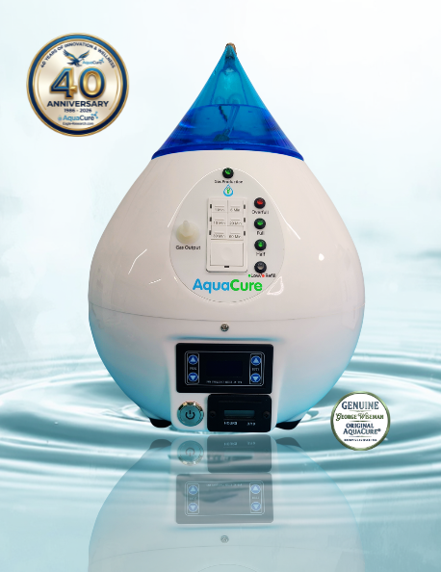
Model AC1

Operation Manual

COPYRIGHT NOTICE
© 2026 George Wiseman all rights reserved licensed for use by, for
Eagle-Research^{ª}, and AquaCure¨.
No Copying or Duplicating permitted of any AquaCure documentation, information, or videos without the express written permission of George Wiseman.
Owners of AquaCure AC1 may download and/or print one copy of the online manual for their own personal use.
Uses of the AquaCure also include applications for plants, aquariums, animal care, mini-torch fuel, and other non-medical environments.
DISCLAIMERS
The statements in this manual have not been evaluated or approved by the FDA or any other government agency, or medical organization. Products discussed or presented are not intended to diagnose, treat, cure, or prevent any disease.
The information provided on or in any product label, packaging, manuals, and associated links are for informational purposes only and are not intended as a substitute for advice from your physician or other health care professionals
AquaCure is not currently classified or approved as a medical device in Canada, United States, or any other jurisdiction. Any references to potential health-related applications are for informational and theoretical purposes only.

LIABILITY
Eagle-Research, AquaCure, its manufacturers, distributors, suppliers, and anyone associated with them assume no responsibility for:
- damage caused by abnormal use or if used in extreme environments
- any damage, losses, or injuries arising from the misuse of any of our AquaCure products. Follow all the instructions described. Do not open the machine to expose the parts. Personal injury could occur.
- changes made to our products by users or owners without written authorization.
Modifications to any AquaCure product must be approved by Eagle-Research, AquaCure, or George Wiseman in writing. All other modifications will be deemed excessive damage and may terminate any, and all warranties.
Use of the Products, information, or services confirms acceptance of these conditions. If these conditions are not acceptable, please immediately return the products for a refund.


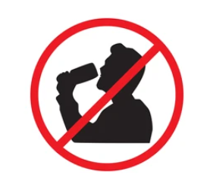
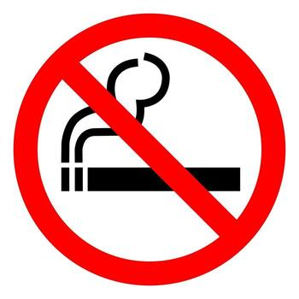

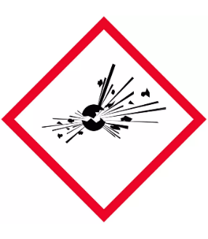
CAUTION!!

All Brown’s Gas (aka Hydroxy, HHO) electrolyzers, including the AquaCure, generate a mixture of hydrogen and oxygen gases that are combustible and potentially explosive. The alkaline solution of Sodium Hydroxide (lye) that is used as a catalyst in the machine for efficient electrolysis is corrosive and can cause chemical burns. It is recommended that you follow safety precautions when working with the lye solution and powder.
- DO NOT ingest (drink) the Lye Mixture, keep away from children.
  - Label stored containers with appropriate labels.
- Wear nitrile or rubber gloves
- Do not inhale the airborne lye particles or the gas emitted during mixing.
- Always mix in a well-ventilated area. Outside or vented stovetop
- Keep off your skin and any other surfaces. If the dry powder gets on your skin, brush it off into the sink and then rinse with tap water until the slippery feeling goes away. If lye, is spilled; use a dry cloth, wipe the powder from the surface into a container, then use a wet cloth or sponge to clean the area until “squeaky clean”
- Do not smoke or have an open flame while using any hydrogen generator
Safety reminders are included in the instructions that follow.

AquaCure AC1 Brown’s Gas Generator Manual
Included in Accessories Box
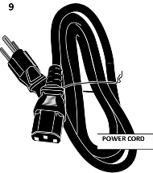
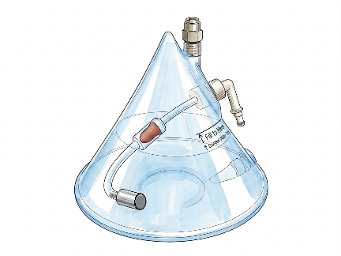
POWER CORD
TOWER CAP (TCP)

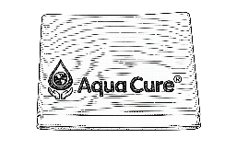
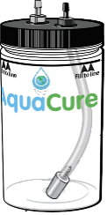
TOWEL
DRINKING WATER JAR
(DWJ)

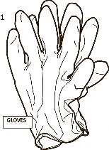
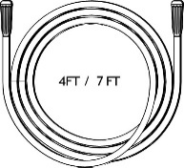
1, 4, and 7 FOOT HOSES
GLOVES
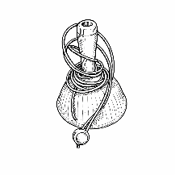
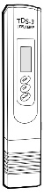
SPOT APPLICATOR
TDS METER

AquaCure AC1 Brown’s Gas Generator Manual
Included in Accessories Box Continued

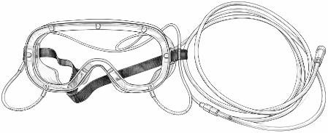
GOGGLES
PLASTIC FUNNEL
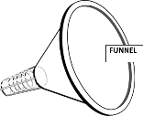

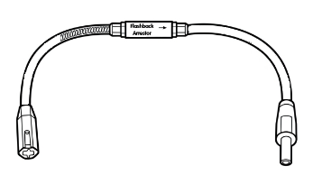
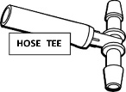
FLASHBACK ARRESTOR
TEE FOR SHARING

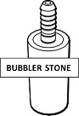
BUBBLER STONE

Not Shown: Cannula, Electrolyte (Sodium Hydroxide)

Setting up your AC1
Need from Home: 1-Gallon Distilled water, Large Class Container (1-2 Liters), and a Stainless-Steel Stirring Utensil (spoon, knife)
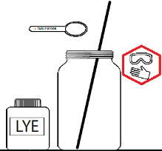
- Fill the glass container with at least 3 cups or 750 mL (half full) of distilled water. Place on a surface that will not be damaged by lye spills. Wear eye protection, do not leave unattended near children, DO NOT INGEST.

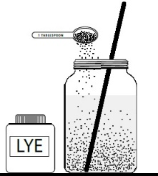

- In a well-ventilated area, start stirring the distilled water, using a stainless-steel utensil. As you stir, slowly pour 4 tablespoons of LYE into the distilled water. Keep stirring until all crystals are dissolved. The solution may become warm and cloudy. Set aside to allow the solution to cool off and become clear. Pouring the Lye too fast can cause a splash, spraying you with the solution.

**You may have received 3 pre-measured Electrolyte packets in this mailing, if so, use ALL 3. Keep the stickers to place on stored jars for safety.
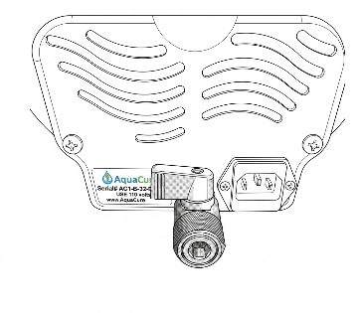
- Make sure the drain valve on the back of the AquaCure is Closed. The lever should be as shown in the picture.
- Plug the power cord into the back of the unit and into the wall. Turn on the main power button on the front lower left side of the machine.
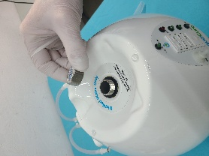
- Once the Solution is clear, remove the silver hexagonal Fill Cap Valve from the top of the AC1 Chassis.

Setting up your AC1
Continued
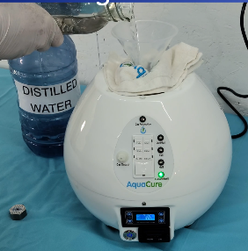
- Insert the included plastic funnel into the fill tube and wrap the towel around the bottom of the funnel.
- Slowly fill the unit with the super saturated lye solution.
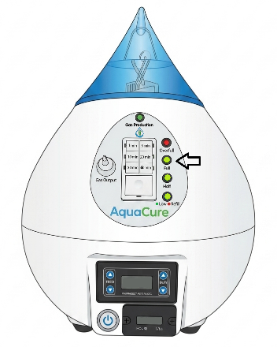
- Top up with Distilled Water until the green “Full” LED turns on.
The machine will hold 2.25 liters / ½ gallon / 9 ½ cups of distilled water inside the electrolyzer. You should have just enough water to complete the filling process.

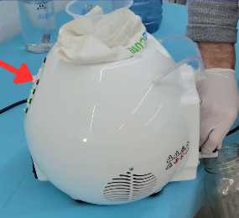
- In the event you accidentally overfill the machine, turn the machine around. Pull it to the edge of the table or counter. Place a container under the valve and open the spigot to allow the extra fluid to drain until the red light goes off.

- Re-Install the fill cap on the fill tube finger tight. Do not over tighten, or “crank” it on. It isn’t necessary and will damage the gasket.

Setting up your AC1
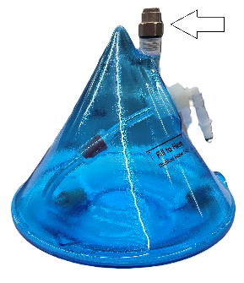
Continued

- Remove the silver hexagonal pressure relief valve from the top of the Translucent blue Bubbler Top (Cone) from the top of the AC60.

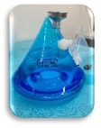
- Using the small stainless-steel funnel, fill the bubbler tank to the fill line indicated on the sticker using only distilled water.

- Re-install the Silver hexagonal pressure relief valve. When you start to feel resistance between the O-ring and the Blue Bubbler Top, STOP. Over torquing the pressure valve will damage the Blue Bubbler Top.

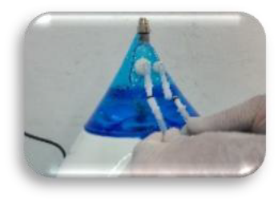
- Set the Blue Bubbler on top of the AquaCure Chassis and connect the hoses on the back of the machine. They will only attach one way.

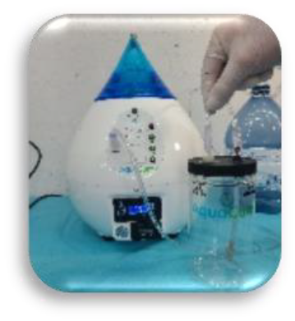
- Fill the Drinking Water Jar up to just below the fill line.

- Attach one end of the vinyl hose (1, 4, or 7 foot) to the Gas output Port, and the other end to the fitting on the Drinking Water Jar. It will be the on the same side as the bubbling stone.

- Attach the Flashback Arrestor to the other fitting on the drinking water jar. Install any hose to the connector on the Flashback Arrestor. (see insert with the Flashback Arrestor) It is not necessary to use the Flashback Arrestor with the machine; it is still safe without it. We have included this part as an extra precaution. Do NOT use the machine while smoking or in the presence of an open flame.

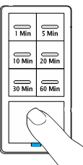
Setting the Timer Switch

  - Using the timer switch on the front of the machine, select the length of time you wish to use the gas. The switch has 6 predetermined times, or you can set the timer to continuous.
  - To change the timer to continuous production, press and hold the bottom button for about 10 seconds. Once you see the blue light illuminate, the machine is set.

Setting your Duty Cycle
Do NOT use the machine while smoking, in the presence of an open flame, or in a dry static prone area. Remove static from your body before engaging the gas from the machine.
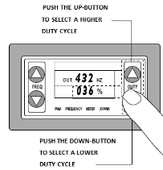
The machine must be turned on to Set your Duty Cycle
- Set your Duty Cycle. Above the Timer Switch there is a PWM meter. The right side adjusts the volume of gas the machine makes. It can be adjusted between 0% (no gas production) & 100% (full gas production). To adjust the %, use the duty buttons on the right side.

- To quickly calculate your safe and optimal breathing limit of 2% hydrogen: Divide your weight (lbs/5 and kg /2.3) to get an optimal breathing %.
EXAMPLE: 180 lbs divided by 5 = 36% or 82kg divided by 2.3 = 36%
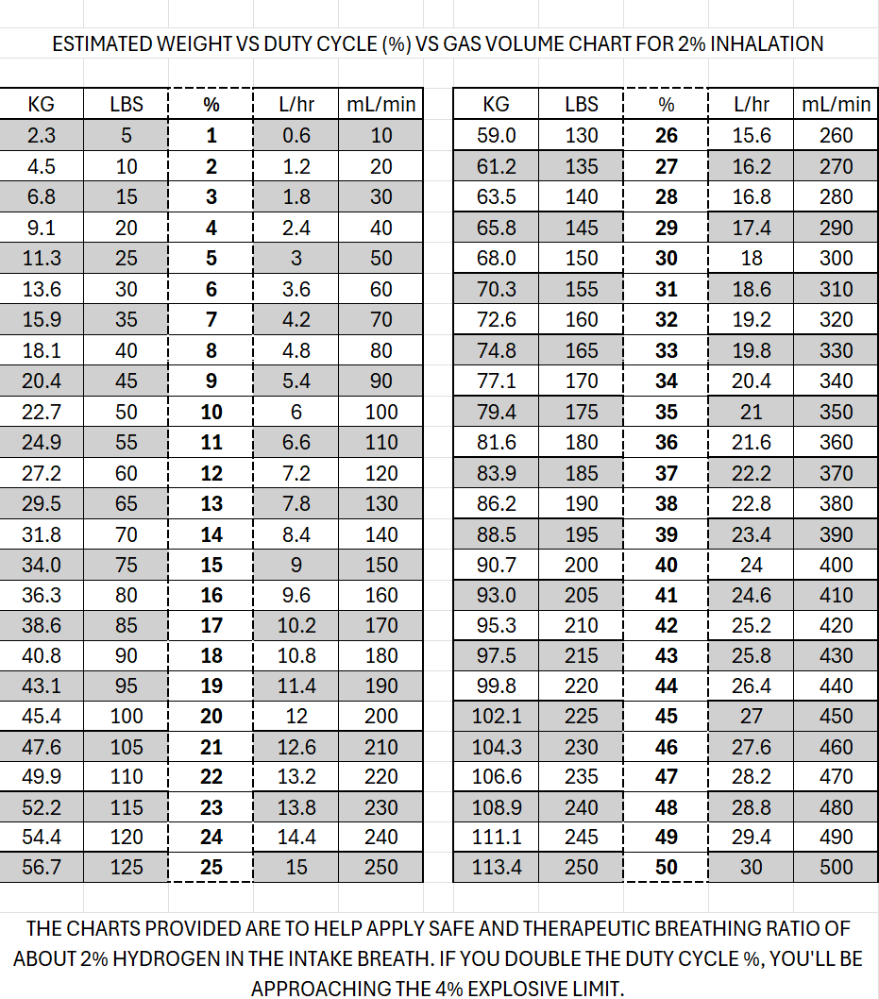

Setting your Duty Cycle
Continued
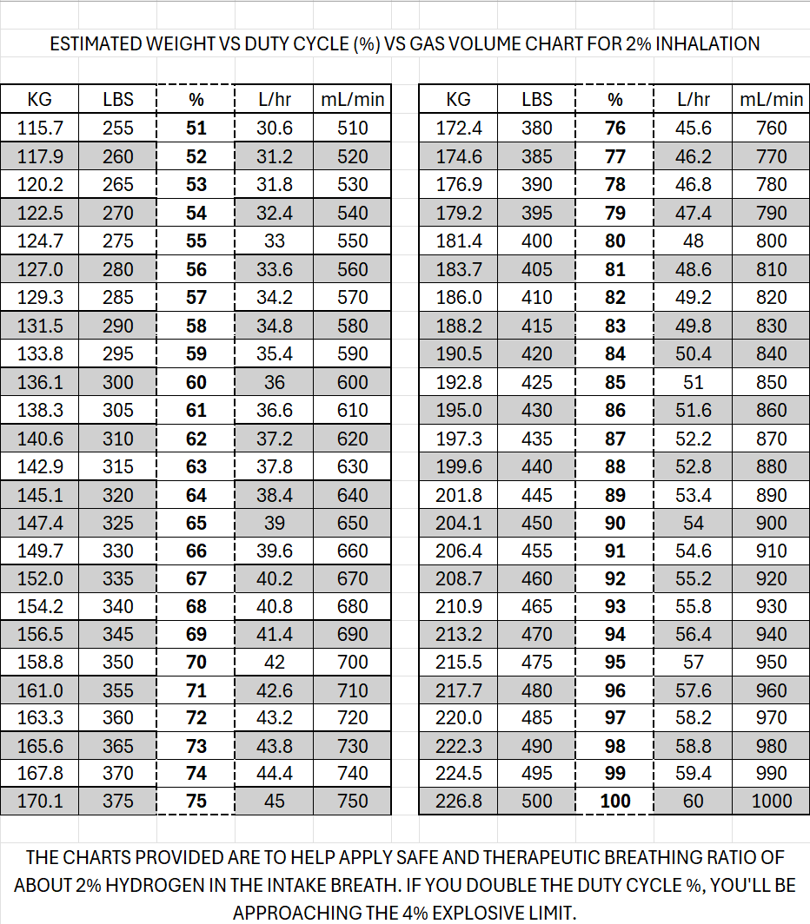

Science has proven that 2% hydrogen in air is the optimal therapeutic limit, therefore, no reason to go near the 4% level
- The standard frequency is set to 432hz. To change the frequency, use the arrow buttons on the left side to adjust. Additional information regarding frequency settings and Duty Cycles are at Eagle-Research.com and AquaCure.Life.

How to Manage the Fluids
You are turning water into gas. The more gas the machine produces the faster the fluids will decrease. When the fluid level on the front of the machine shows green light “LOW”, it is a good time to top up the tank.
Note: If the red light ‘REFILL' turns on, the machine will stop producing gas. The green “Gas Production” light will shut off. If you intend to use the machine during the night, ensure the machine is at least half full. It holds at least ½ gallon of fluid and at 40% will last about 250 hours.
With the machine on:

- Disconnect the 2 hoses between the AC1 chassis and the Blue ​ Bubbler Top remove from the top of the chassis to reveal the silver hexagonal water fill cap.
- Remove the hexagonal cap from the water fill tube. Insert the plastic funnel.
- Remove the pressure relief valve from the top of the blue bubbler and pour the water into the electrolyzer. The bubbler fittings do allow water to pass through; make sure you have them above the pouring fluid.
- Top Up the Electrolyzer with fresh distilled water until the green “FULL” light is on.
- Re-install the silver hexagonal fill tube cap. Do not over tighten, or “crank” it on. It isn’t necessary and will damage the gasket.
- Refill the Blue Bubbler Top to the fill line indicated on the sticker.
- Re-install the pressure relief valve. When you start to feel resistance between the O-ring and the Blue Bubbler Top, STOP. Over torquing the pressure valve will damage the Blue Bubbler Top.
- Place the Blue Bubbler Top (Cone) back on the chassis and plug in the hoses.

Basic Regular Maintenance
Continued

Our experience is that maintenance cleanings of the AC1 can be done every 1000 hours, counted by your hour meter. The meter will reset after 99999 hours, so it is important to keep a log of your maintenance. You can wait until your machine needs to be refilled before doing the rinse, if you are close to the designated hours.
- Disconnect the 2 hoses between the AC1 chassis and the Blue Bubbler Top (Cone), and remove from the top of the chassis to reveal the silver hexagonal water fill cap.
- Remove the hexagonal cap from the fill tube.
- Turn the machine around and place a bucket under the drain tube. You can also drain the fluid directly into a sink.
It is recommended to reuse the electrolyte solution after rinsing the machine. Put the fluid in a clean lye glass container that is labelled with the reusable lye powder sticker provided with your order. Allow the solution to settle (clarify) before pouring it back in. If the fluid does not settle, or has become contaminated (foaming, brown muddy colour), throw it out and mix new electrolyte.
- Open the drain valve by turning the lever counter-clockwise ¼ turn. It will only go that far. Allow the solution to drain. Raising the front of the machine will allow all the solution to drain out. The pipe is narrow and may take a few minutes to allow the solution to drain.
Note: The electrolyzer will hold 2.25 liters (1/2 gallon, 9.5 cups) of solution when full. If the drain seems plugged, you can insert a straw cleaning brush or wire to unplug it; just bend the wire so that your hand isn't in the flow of solution that comes out. The solution will sting if it has contact with open cuts. It is advisable to wear rubber gloves.
- Once the machine is empty, close the drain valve.

- Pour HOT tap water into the fill tube of the AC1 until the green “FULL” light comes on.

- Rock (tip) the machine back and forth to allow the fluid to rinse the electrolyzer. There are finger holds on the bottom of the machine. There is no need to shake or turn the machine upside down.

Basic Regular Maintenance

- Drain the water into a bucket or sink by opening the drain valve. Once there is no more water, close the drain valve. Repeat, if necessary, with fresh HOT tap water until the water is clear.
- Pour clarified solution into the machine using the plastic funnel. Do not allow any sludge or debris to be put back into the machine.
- Top up the electrolyzer using distilled water. Follow the filling procedure in the start-up video or the refilling process or continue below.
- Once the green light “FULL” is on, re-install the silver hexagonal fill tube cap. Do not over tighten, or “crank” it on. It isn’t necessary and will damage the gasket.
- Return the full Blue Bubbler Top (Cone) to the top of the chassis.
- Connect the 2 hoses between the Blue Bubbler and the Chassis.
PRO-TIP: Having TWO electrolyte solutions, makes things easier. You can allow the emptied fluid to settle completely while filling the machine with saved solution. It could take up to 3 days to fully clarify (settle). We store our electrolyte in glass “mason” jars with plastic lids, clearly labelled to prevent anyone from ingesting it.

Warranty & Guarantee

100% Satisfaction Guarantee
We stand behind our technology. First-time buyers can evaluate the AquaCure risk-free. If you are not completely satisfied with the results within your initial trial window, you may return the unit for a refund of the purchase price, less a $200 restocking fee. *See website for more information.
Our Warranty & Lifetime Support
- Manufacturer Defects: Full coverage on parts, labor, and shipping for the original purchaser (non-transferable).
- Out-of-Warranty / Second-hand Items: If your warranty is invalid due to user damage or resale, we won't abandon you. We will repair any issue with the condition that the customer pays for parts, labour, and shipping.
Since 1984, Eagle-Research has stood by its craftsmanship, and we plan to do so for at least another two decades. We still service every product we have ever made. If you need a repair outside of warranty, we offer lifetime support, the owner simply covers parts, labor, and shipping.
Return Authorizations: Please contact us directly through the official support portals at Eagle-Research.com or AquaCure.Life. Do not ship any units back without a pre-authorized Return Merchandise Authorization (RMA).

ADDITIONAL INFORMATION
Thank you again for our purchase. We hope you enjoy the benefits as much as we do.
Several videos are available on our website Eagle-Research.com or AquaCure.Life.

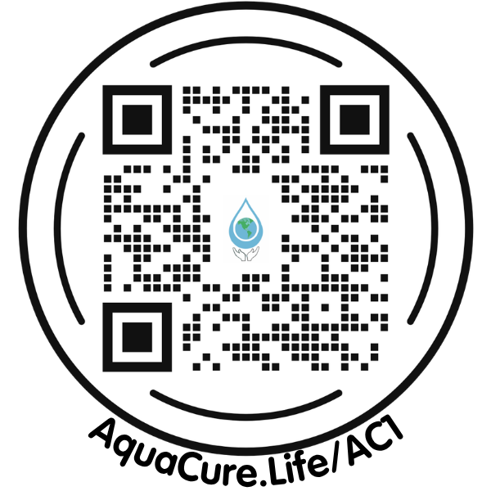

If you cannot find your answer on the website, please reach out to us at
Eagle-Research.com/contact or AquaCure.Life/contact.
We will work through it with you.

